**Patient registration use case: -**

|  |  |
| --- | --- |
| **Name** | Patient Registration |
| **Brief Description** | The Patient Registration use case allows the User to create a login and become a registered user. |
| **Actor(s)** | Patient |
| **Flow of Events** | |
| **Basic Flow** | |
| This use case starts when the User accesses the system feature that enables him/her to create an account by entering information that is maintained in database.   1. The Patient enters the required information values and requests that the system saves the entered values. 2. The system validates the entered *patient information*. 3. The system notifies the User that the account has been created. 4. The use case ends | |
| **Alternate Flows** | |
| **Title** | **Description** |
| Patient Cancels Request | At any time, the User may choose to cancel the account creation. At which point, the processing is discontinued, the user account remains unchanged, and the user is notified that the account management request has been cancelled. |
| Patient Enters Invalid User Account Information | If during Create Account, the system determines that the User entered invalid Patientinformation, the following occurs:   1. The system describes which entered data was invalid and presents the User with suggestions for entering valid data. 2. The system prompts the User to re-enter the invalid information. 3. The User re-enters the information and the system re-validates it. 4. If valid information is entered, the User Account Information is stored. 5. If invalid information is entered, the Entered Information is Invalid alternative flow is executed again. This continues until the User enters valid information, or chooses Cancel.   Invalid Patient information:   * Missing information items * Username already exists in the system; * *User Account* information entered does not comply to its definition in the glossary * Not well formed e-mail address * Offending words in any part of the *User Account* information |
| **Pre-Conditions** | |
| **Title** | **Description** |
| None | User is not a member of the system. |
| **Post-Conditions** | |
| **Title** | **Description** |
| Success | The User entered data is stored in the user account. Confirmation is sent to the appropriate email address. |
| The user account was not created | The User entered invalid data or chose to cancel the account creation request. In either case, no account will be created. |
| **Extension Points** | |
| None | |

Fields for patient registration: -

* Id (System generated)
* Name
  + First name
  + Middle name
  + Last name
* User name (Text box)
* Password (Text box)
* Retype password (Text box)
* Date of birth (Date picker)
* Phone No (Text box)
* Sex (Radio button)
* Email (Text box)
* Previous medication details (Text area)

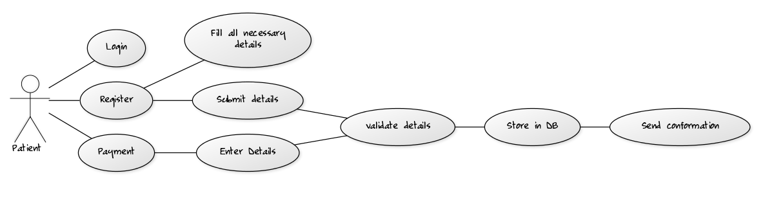

**Doctor registration use case: -**

|  |  |
| --- | --- |
| **Name** | Doctor Registration |
| **Brief Description** | The Doctor Registration use case allows the doctors to create a login and become a registered user. |
| **Actor(s)** | Doctor |
| **Flow of Events** | |
| **Basic Flow** | |
| This use case starts when the User accesses the system feature that enables him/her to create an account by entering information that is maintained in the User’s account.   1. The User enters the required *User Account* information values and requests that the system saves the entered values. 2. The system validates the entered *User Account* information. 3. The values for the *User Account* information are stored in the User’s account. The system notifies the User that the account has been created. 4. The use case ends | |
| **Alternate Flows** | |
| **Title** | **Description** |
| User Cancels Request | At any time, the User may choose to cancel the account creation. At which point, the processing is discontinued, the user account remains unchanged, and the user is notified that the account management request has been cancelled. |
| User Enters Invalid User Account Information | If during Create Account, the system determines that the User entered invalid *User Account* information, the following occurs:   1. The system describes which entered data was invalid and presents the User with suggestions for entering valid data. 2. The system prompts the User to re-enter the invalid information. 3. The User re-enters the information and the system re-validates it. 4. If valid information is entered, the User Account Information is stored. 5. If invalid information is entered, the Entered Information is Invalid alternative flow is executed again. This continues until the User enters valid information, or chooses Cancel.   Invalid *User Account* information:   * Missing information items * Username already exists in the system; * *User Account* information entered does not comply to its definition in the glossary * Not well formed e-mail address * Offending words in any part of the *User Account* information |
| **Pre-Conditions** | |
| **Title** | **Description** |
| None | User is not a member of the system. |
| **Post-Conditions** | |
| **Title** | **Description** |
| Success | The User entered data is stored in the user account. Confirmation is sent to the appropriate email address. |
| The user account was not created | The User entered invalid data or chose to cancel the account creation request. In either case, no account will be created. |
| **Extension Points** | |
| None | |

Fields for Doctor registration: -

* Id (System generated)
* Name
  + First name
  + Middle name
  + Last name
* User name (Text box)
* Password (Text box)
* Retype password (Text box)
* Date of birth (Date picker)
* Phone No (Text box)
* Sex (Radio button)
* Email (Text box)
* Specialization (Drop down)

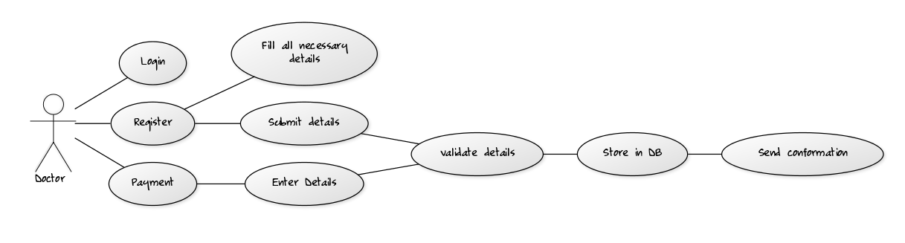

**Technician registration use case: -**

|  |  |
| --- | --- |
| **Name** | Technician Registration |
| **Brief Description** | The Technician Registration use case allows the Technician to create a login and become a registered user. |
| **Actor(s)** | Technician |
| **Flow of Events** | |
| **Basic Flow** | |
| This use case starts when the User accesses the system feature that enables him/her to create an account by entering information that is maintained in the User’s account.   1. The User enters the required *User Account* information values and requests that the system saves the entered values. 2. The system validates the entered *User Account* information. 3. The values for the *User Account* information are stored in the User’s account. The system notifies the User that the account has been created. 4. The use case ends | |
| **Alternate Flows** | |
| **Title** | **Description** |
| User Cancels Request | At any time, the User may choose to cancel the account creation. At which point, the processing is discontinued, the user account remains unchanged, and the user is notified that the account management request has been cancelled. |
| User Enters Invalid User Account Information | If during Create Account, the system determines that the User entered invalid *User Account* information, the following occurs:   1. The system describes which entered data was invalid and presents the User with suggestions for entering valid data. 2. The system prompts the User to re-enter the invalid information. 3. The User re-enters the information and the system re-validates it. 4. If valid information is entered, the User Account Information is stored. 5. If invalid information is entered, the Entered Information is Invalid alternative flow is executed again. This continues until the User enters valid information, or chooses Cancel.   Invalid *User Account* information:   * Missing information items * Username already exists in the system; * *User Account* information entered does not comply to its definition in the glossary * Not well formed e-mail address * Offending words in any part of the *User Account* information |
| **Pre-Conditions** | |
| **Title** | **Description** |
| None | User is not a member of the system. |
| **Post-Conditions** | |
| **Title** | **Description** |
| Success | The User entered data is stored in the user account. Confirmation is sent to the appropriate email address. |
| The user account was not created | The User entered invalid data or chose to cancel the account creation request. In either case, no account will be created. |
| **Extension Points** | |
| None | |

Fields for Technician registration: -

* Id (System generated)
* Name
  + First name
  + Middle name
  + Last name
* User name (Text box)
* Password (Text box)
* Retype password (Text box)
* Date of birth (Date picker)
* Phone No (Text box)
* Sex (Radio button)
* Email (Text box)
* Technical details

